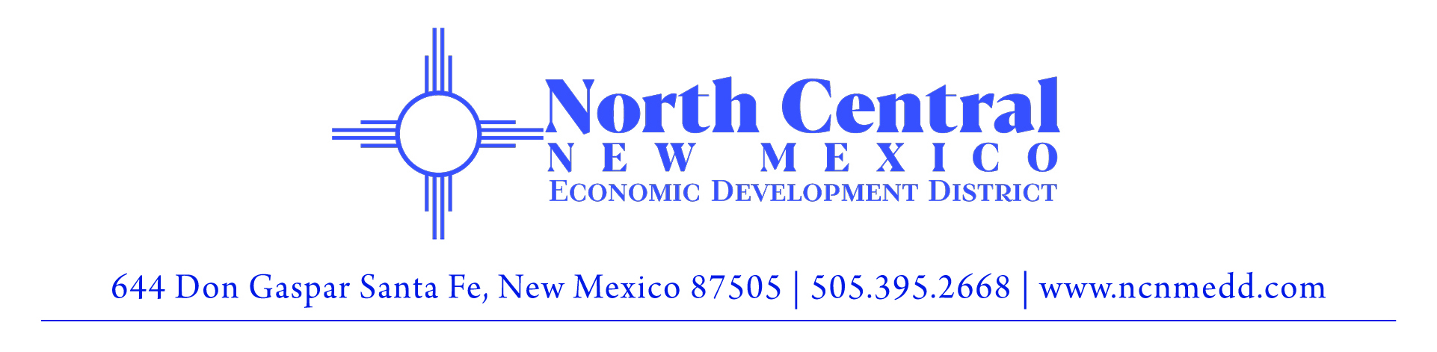

Request for Qualifications (RFQ) FY 2025-01
Community Based Projects in the North Central Region
Posted July 3, 2024

In the 2024 Legislative Session, $160,000 was appropriated to the North Central Economic Development District (NCNMEDD) for community based projects in the north central region for expenditure by July 30, 2026.

This RFQ allows non-profit organizations and public entities to submit proposals for these funds.

Organizations or entities applying for these funds must be based in New Mexico and should be established organizations with strong records of positively impacting the community.

Proposals are due on July 15, 2024 at 5:00 pm.

Responses to this Solicitation
Proposals should be brief; no more than 5 pages total, including the Narrative and Budget form.

Please email the following information in a single .pdf document to monicaa@ncnmedd.com no later than 5:00 pm on Monday, July 15, 2024:

- Signed letter of interest or cover letter, attesting to accuracy of all information provided.
- Statement of qualifications for the organization or entity.
- Bios or resumes of the lead and other team members who will manage the project.
- Three professional references for which your team has performed similar work. Please list name, title, contact information, and work performed.
- Completed narrative and budget form. (see page 2 and 3)

NARRATIVE AND BUDGET FORM

Organization/Entity Name:
Address:
Website:

Contact Person:
Title:
Email:
Phone Number:

1. In the text box below, provide a brief NARRATIVE of the community-based project or program for which you are requesting funding. Project or programs should be scalable as we hope to fund two or more projects or programs.

2. In the text box below, provide PERFORMANCE MEASURES you will use to monitor and track the impact of the proposed project or program.

3. Fill out the table below to provide a BUDGET for the two-year period of the funding. The budget should not exceed $50,000 per year. Please add additional lines as needed.

Line Item | Year 1 Budget  (Aug 2024-June 2025) | Year 2 Budget  (July 2025-June 2026) | Description of Line Item
Personnel
Benefits
Professional Services
Travel (GSA rates apply)
Software
Equipment/Supplies
Operations (specify)
Operations (specify)
Other (specify)
Other (specify
Total

